|  |  |
| --- | --- |
| ihealthgsfm.com  USER GUIDE | This document serves as a guide to our website visitor. It contains details information on how to use the website conveniently. |

**CONTENT**

**Title Page**

1. INTRODUCTION -------------------------------------------------------------------------------------- 3
2. HOME PAGE -------------------------------------------------------------------------------------------- 4
3. LOGIN AND REGISTRATION ------------------------------------------------------------------------- 5
   1. LOGIN ----------------------------------------------------------------------------------------------- 5
   2. REGISTRATION ------------------------------------------------------------------------------------ 6
4. DASHBOARD ------------------------------------------------------------------------------------------ 9
   1. ING USER DASHBOARD ------------------------------------------------------------------------- 10
   2. NORMAL USER DASHBOARD ------------------------------------------------------------------ 13
5. IHEALTH NETWORKING GROUP ------------------------------------------------------------------- 14
6. HOW TO REGISTER BUSINESS OR PRODUCT ---------------------------------------------------- 17
7. **INTRODUCTION**

**IHealthGSFM** – Nigeria’s premiere meeting point of quality health, good technology and easy access. Our core aim is to make quality healthcare more accessible to you by providing a holistic healthcare services that use technology to give you this access, via our website [*(www.ihealthgsfm.com)*](https://localhost:44301/) and other relevant websites that provide quality healthcare services from around the globe.

Our website will give you access to dynamic healthcare platforms, diverse specialists and health experts in different fields of health and countries, all in real time. We also monitor and evaluate quality and standards in the health industry through our review and rating system that provides you with useful hints before access them. We also promote investments in healthcare through equity funding, health insurance provision and the provision of foreign linkages for guaranteed credit purchases and supplies etc. We equally provide top-quality health management services for HMOs and related organizations.

The document will provide you a detail guide on how to use our website effectively. If you have any question that is not covered in this user guide, please contact us using this link [http://ihealthgsfm.com/support/contactus](http://ihealthgsfm.com/support/contactus%20)

1. **HOME PAGE**

The URL to the homepage is <http://ihealthgsfm.com>

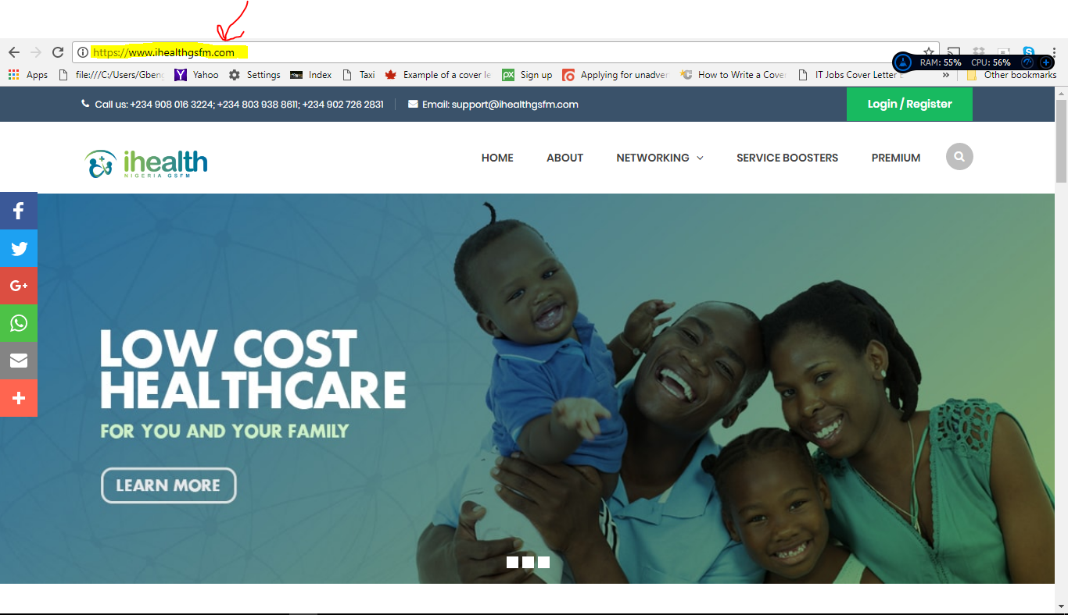

Fig.1 ihealthgsfm.com home page

This is the landing page to our website, with other links which gives you access to other pages on the website.

1. **LOGIN AND REGISTRATION**
   1. **LOGIN**

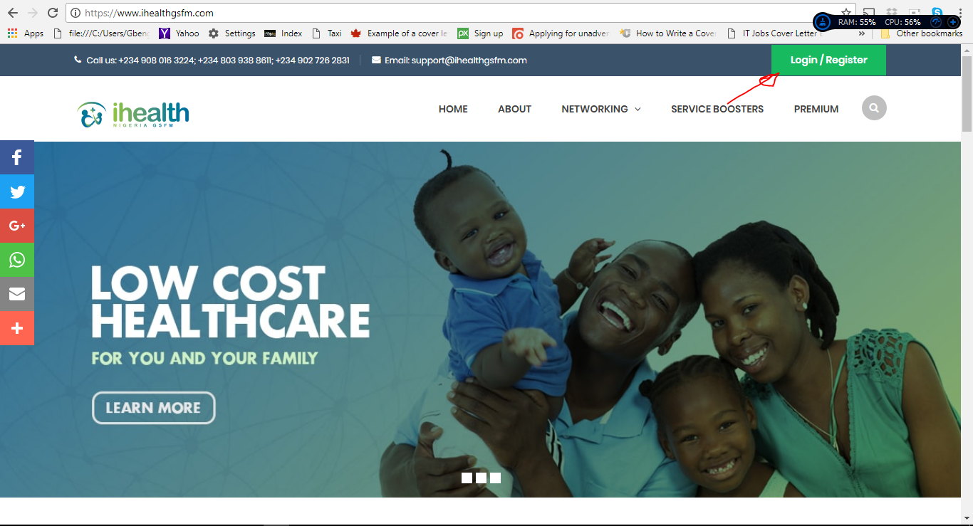

Fig.2. Arrow point to login button

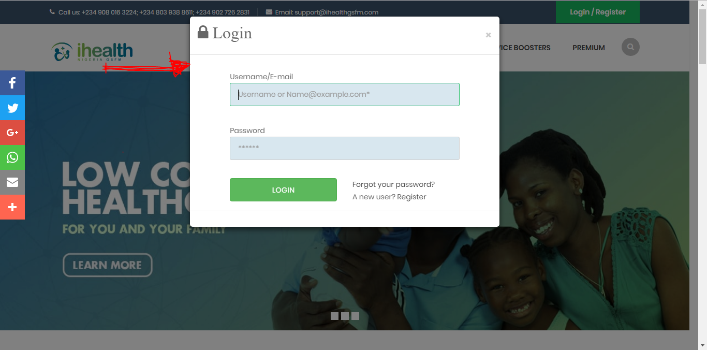

Fig.3 login form

Users who are already registered on our site can click the login/register button at the top right corner on the website or visit <http://ihealthgsfm.com/account/login>. And then proceed to supply their login credentials (i.e. username/Email and password). Also on the login form are ***forgot password*** and ***registration*** link.

* 1. **REGISTRATION**

The registration page has two (2) separate register button. One of the button once clicked gives you access to register as a member of ***iHealth Networking Group (ING)***, while the other gives you access to register has a ***Normal user*** on our website.

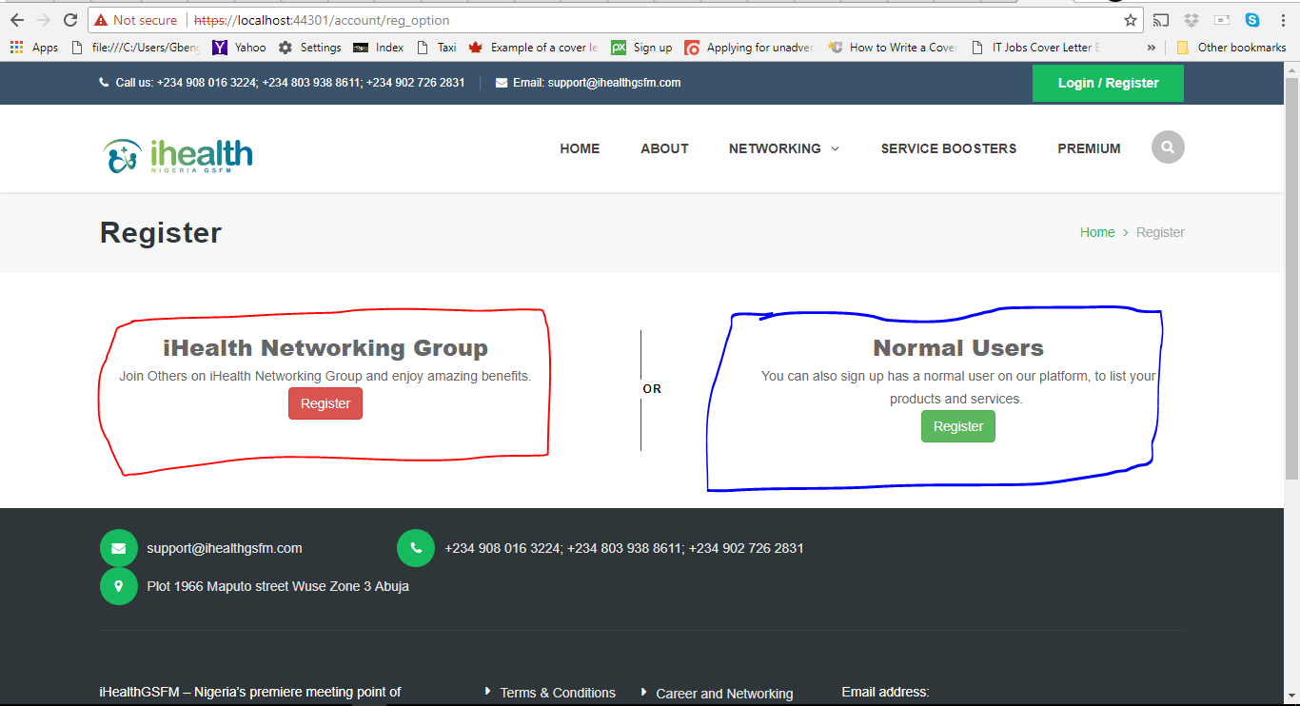

Fig.4 Registration page

***IHealth Networking Group (ING) HHJjjjjjjjjjjjjjhhhh*** members enjoy some benefits that a ***Normal user***does not have access to. With a onetime payment of just a token, you can register as a member of iHealth Networking group. Our site user who register as a normal user can upgrade to the iHealth networking group platform at any time within their dashboard. To find out more about iHealth Networking Group visit <http://ihealthgsfm.com/ING/networking>

**Registration Form**

The iHealth Networking Group and Normal users register form have similar input section’s field with only just a few differences. The major difference between both forms are the fields marked with number 1, 3 and 4 in the fig 5.

|  |  |
| --- | --- |
|  |  |

Fig.5 ING Register Form

The iHealth Networking Group register form is divide into sections, with each sections containing input field which are self-explanatory. The field mark with numbers are explain below.

1. Become a service boosters: this field allows professionals in the health sector to either choose to become a service booster on our platform. To find out more about service booster visit [http://ihealthgsfm.com/ing/ClientBooster](http://ihealthgsfm.com/ing/servi)
2. Security Information field: in this section, new user can supply their username and password.
3. Referrer Information: if new user is referred by an existing, the new user is expected to supply the referrer code of his/her sponsor.
4. Payment information: in this section new user can choose to either pay with card of or pay directly to bank.

***Note:*** *the following takes place after registration form has been field and submitted*

1. *An email is sent to newly register user.*
2. *The information contained the email will guide the user on the next steps in his/her registration process.*
3. *Once registration process is completed, user can proceed to login by supplying their username or email and password.*
4. **DASHBOARD**

After user login is successful, a button appear as shown in fig.6, kindly click the button to proceed to dashboard.  
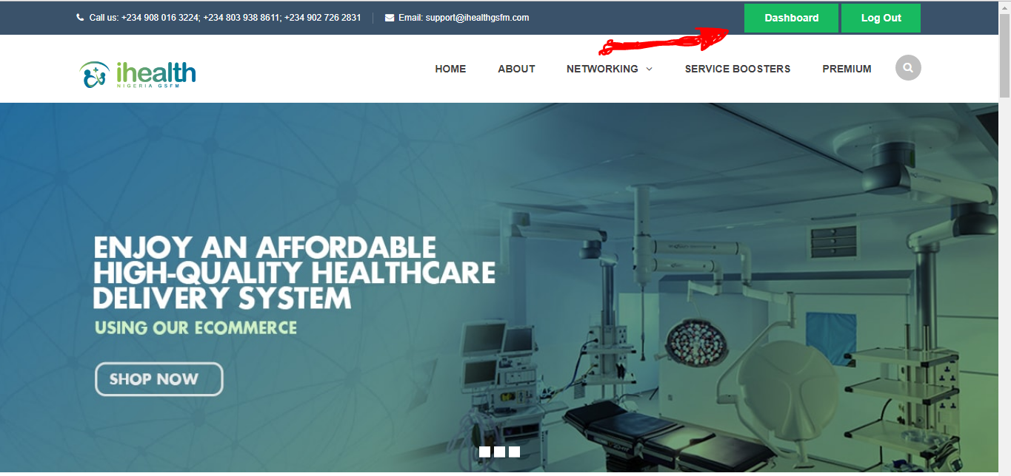

Fig.6 Access to user dashboard

***NOTE****: iHealth Networking Group (ING) Member’s dashboard is slightly different from the Normal user’s Dashboard.*

* 1. **ING USER DASHBOARD**

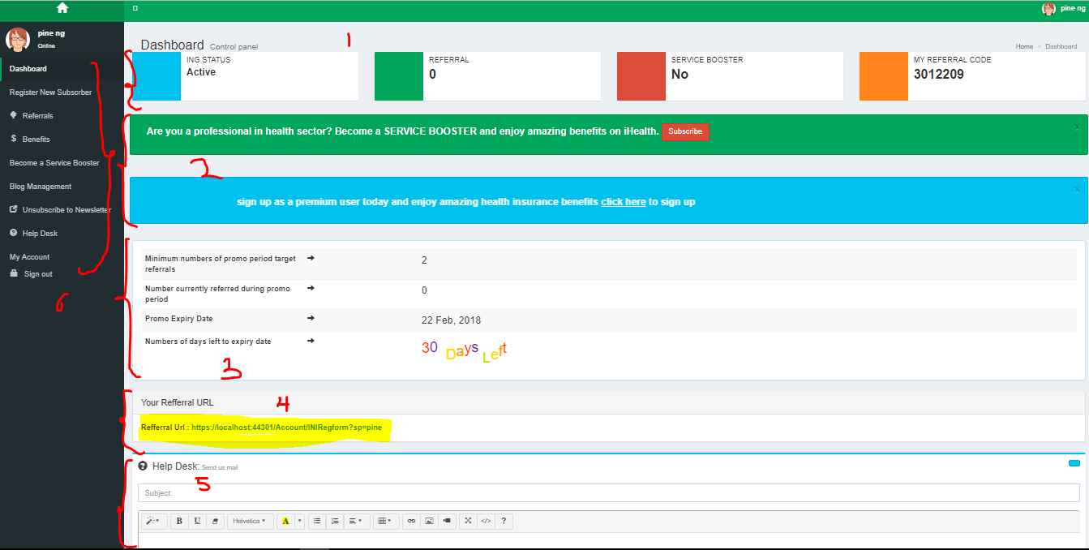

Fig.7 ING User Dashboard

Fig.7 shows how ING user’s dashboard looks like. The fields that are number in fig.7 are explained below

1. Status Bar: this section contain some information such ING Status, Referral number(i.e. Downline size), Service Booster Status, Referral Code
2. Information Bar: this section contain information or news that users can act upon
3. Promotion Bar: this section appears only if user have an active promotional period. It contain information such as
4. Minimum number of promo period target referrals: i.e. the number of referral that a user need in order to qualify for promo benefits.
5. Number currently referred during promo period
6. Promo expiry date
7. Numbers of days left to expiry date: this number automatically count down.
8. Referral URL: user can copy and share this link to invite others to the platform.
9. Help Desk: user can contact ihealth support team using this section
10. Side Bar: this bar contain section that user can use to access other pages.

|  |  |
| --- | --- |
| Fig.8 Side bar for an iHealth Networking member who is a service booster. | Fig.9 Side bar for an iHealth Networking member who is not a service booster |

**SIDE BAR DETAILS**

1. Register New Subscriber: once clicked it allow existing user to register new user who automatically become his/her downline.
2. Referral: this has three (3) sub-menu has shown in fig.10. This allow user to view his/her downlines and also see accrued bonuses.

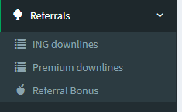

Fig. 10 Referrals Sidebar Menu

1. Benefits: this has two submenu has shown in fig.11. The claim benefit link allows iHealth networking members to claim their benefits or bonuses, secondly, the benefit history allow users to view history of already claimed benefits.

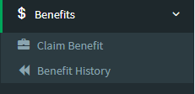 Fig.11. Benefits Sidebar Menu

1. Business/Service manager: this section only displays on the dashboard of a service booster. It has two (2) submenu as shown in fig.12. List a service allows service boosters to create or registered their services or business. while already registered businesses or services can be view by clicking the *my business/services* link

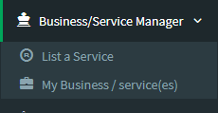 Fig. 12. Business/Service Manager Sidebar menu

1. Product manager: this section only displays on the dashboard of a service booster. It has two (2) submenu as shown in fig. 13. Service boosters can register a product by clicking the first link and can view all registered products by clicking the second link.

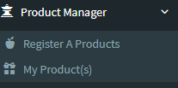Fig. 13. Product Manager Sidebar menu

1. Blog Management: this section only displays on the dashboard of a service booster. This section allows service boosters to publish articles on our website. It has three(3) submenu as shown in fig.14

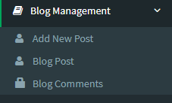 Fig. 14. Blog Management Sidebar menu

1. My Account: this section has three submenu as shown in fig.15. Users can manage their bank detail, change password and manage profile.

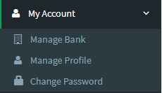 Fig. 15. My Account sidebar menu

* 1. **NORMAL USER DASHBOARD**

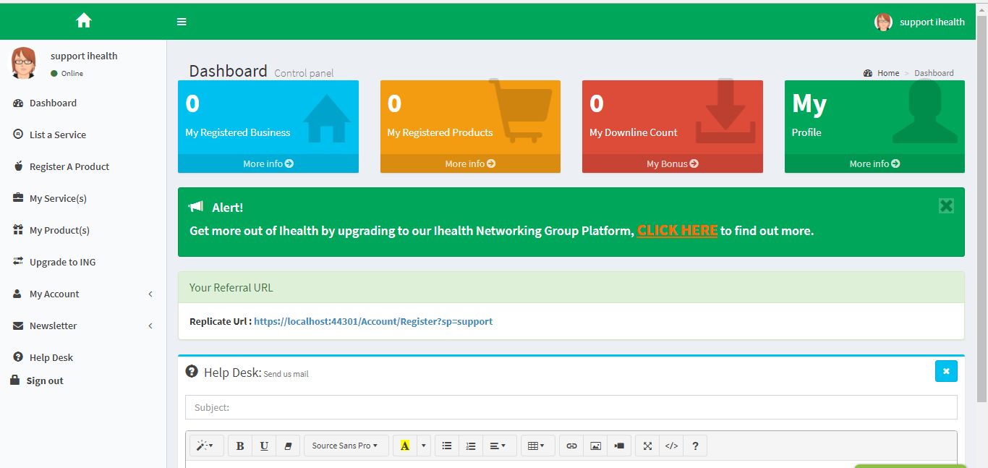

Fig. 16. Normal User Dashboard

1. **IHEALTH NETWORKING GROUP GUIDE**

After registration process is completed, ING promotional period is automatically activated. Fig.17 shows the number of downlines required by member before the end of the promotional period, the maximum number of days required to meet target, promo period expiry date and the number of downline that sign up using member’s referral code during the promo period.

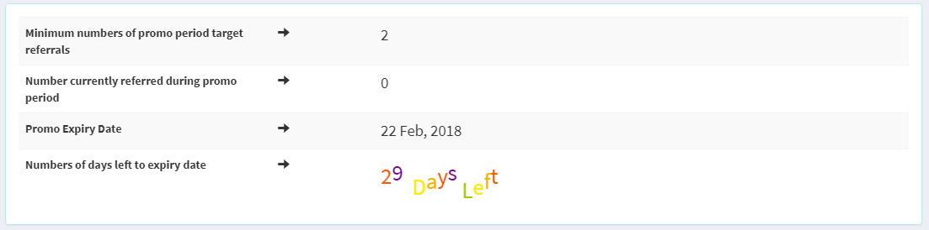

Fig. 17. Promotional Bar

**HOW TO CLAIM BENEFITS OR BONUSES**

Once promotional period has ended member user can proceed to claim benefits or bonuses if any.

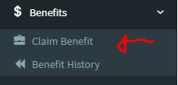 Fig. 18. Benefit Side Menu

How claim benefits works

1. Click on the claim benefit link as shown in fig. 18
2. User will receive an email on the as soon as the benefits request is submitted successfully.

**NOTE:**

1. *If user meet the required downline target within the promo period, he or she will be able to select either health or cash benefits as shown in fig.19. Otherwise he/she will be place automatically on cash benefits.*
2. *For users who does not have any bonus after the promo period has ended, will not qualify for any benefits and a link will appear on their page as shown in fig.20 to re-activate promotion.*
3. *For user who successfully submitted benefits claim, once the benefits is processed by the admin, a new promotional period is automatically activated for the user.*

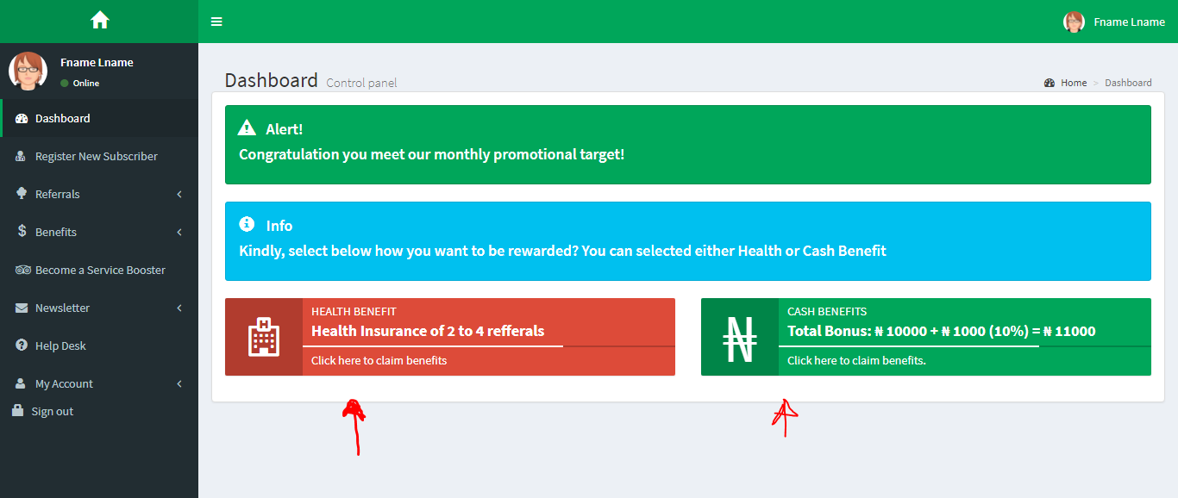

Fig. 19. Claim Benefit Option Page

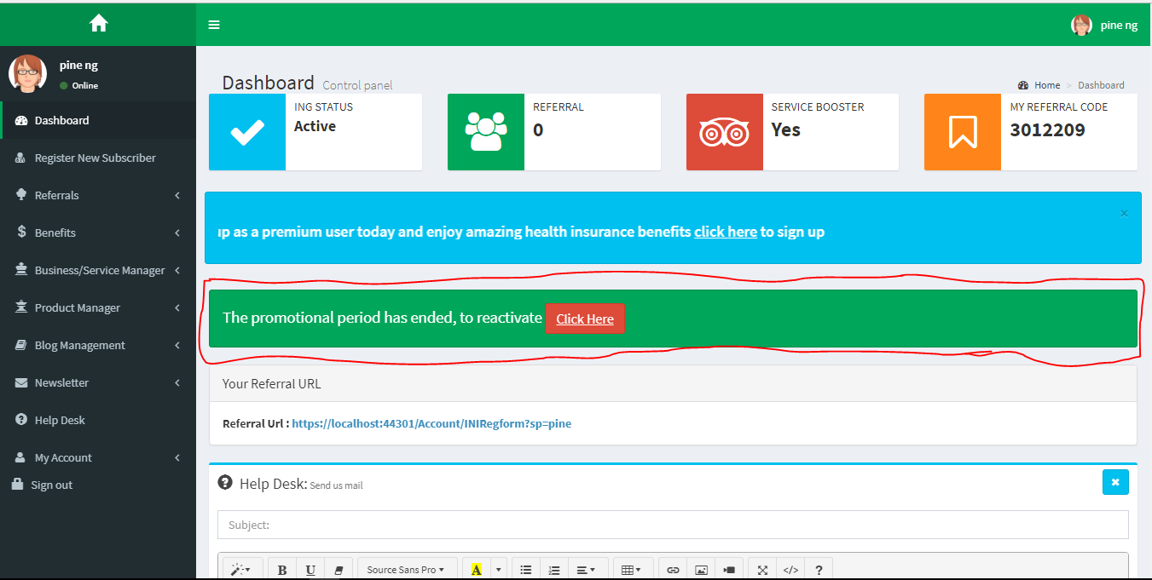

Fig.20. Reactivate Promotions

**NOTE:** *Service Booster Members must first proceed to register their business or service first before they can have a view of the dashboard. Otherwise the dashboard as shown in fig. 21. With a message informing service boosters to register business or service.*

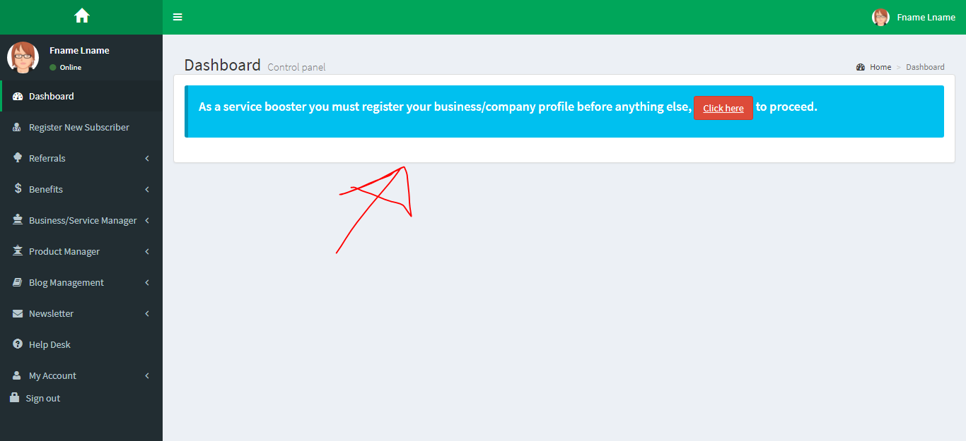

Fig. 21. Service Booster without a register business or service

1. **HOW TO REGISTER A BUSINESS OR PRODUCT**
2. For Normal User,
3. Click on *register product* for product registration or *list a service* for Business registration.
4. Fill the form that appears and submit.
5. Once form is submitted an email will be send to user.
6. For iHealth Network Group member (i.e. **Service Boosters**)
7. Click on Business Manager to list a service or click on product manager to register products as shown in fig. 12 and fig. 13
8. Fill the form that appears
9. Once form is submitted an email will be send to user.

**NOTE:** *Once a business or product is registered, owner of such business will wait for the business or product to be approved by our admin before it can be listed on our website.*